**House Sales Analysis Dashboard Report**

**Introduction**

This report presents an analysis of house sales data visualized through a Tableau dashboard. The dashboard provides a comprehensive view of various factors influencing house prices in Washington state, including property views, conditions, year built, and distribution of bathrooms. The analysis is designed to help stakeholders understand the key trends and insights from the dataset.

**Dataset Overview**

The dataset used for this analysis contains information on house sales in Washington state. Key attributes include:

* **House Prices:** Sale prices of houses.
* **View:** Quality of the view from the house, categorized as 'Average,' 'Fair,' 'Good,' 'Poor,' 'Excellent,' etc.
* **Condition:** The overall condition of the house.
* **Year Built:** The year the house was constructed.
* **Bathrooms:** Number of bathrooms in the house.
* **Date:** The date of the sale.

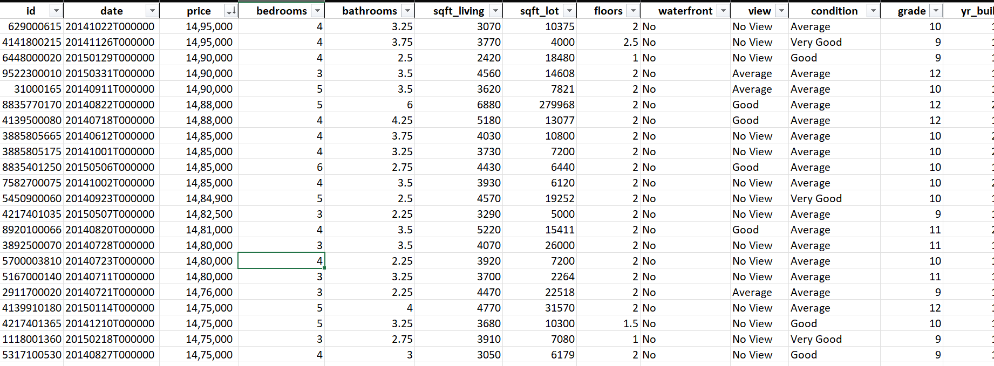

**Dashboard Overview**

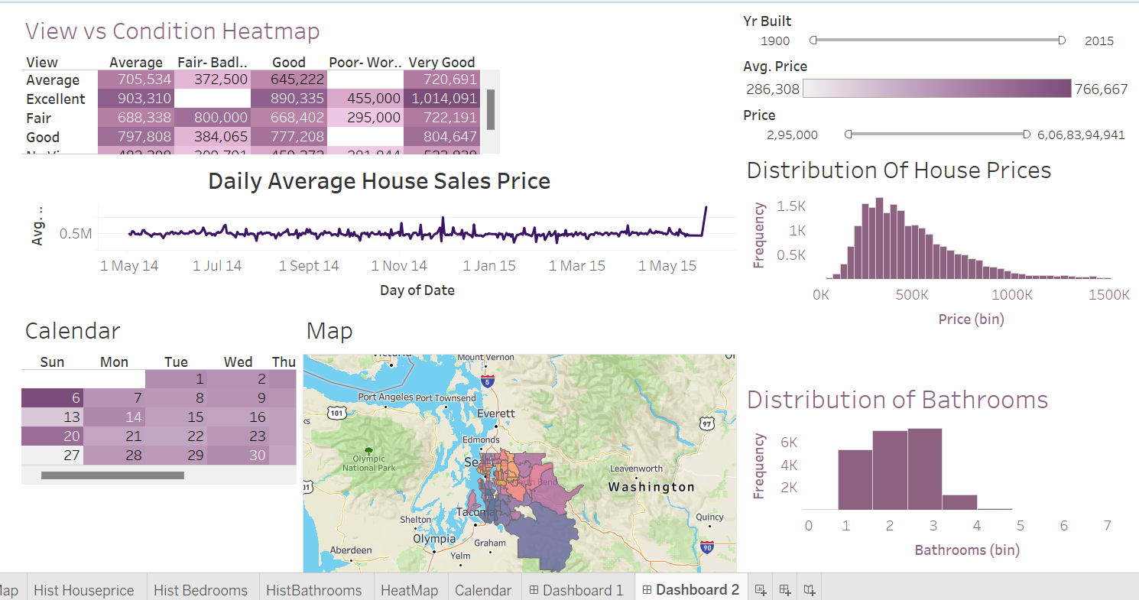

The dashboard is divided into several key visualizations that each serve a specific purpose in understanding the data:

**1. View vs Condition Heatmap**

This heatmap displays the relationship between the quality of the view and the condition of the house, with the corresponding average sale prices.

* **Insight:** Houses with an 'Excellent' view and in 'Very Good' condition tend to have the highest average sale price, suggesting a strong correlation between these factors and the value of the property.

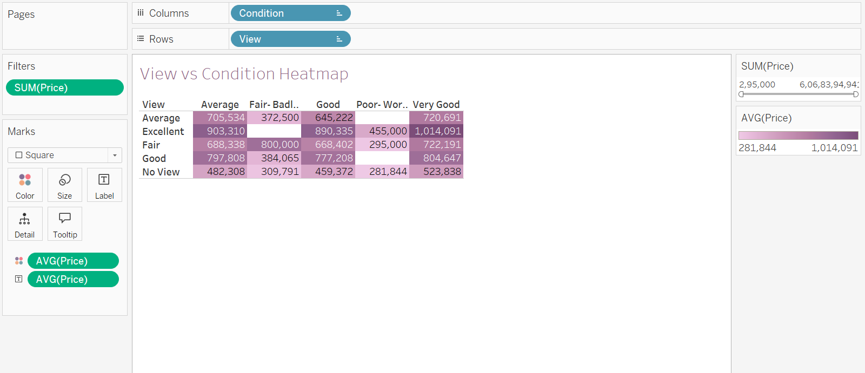

**2. Daily Average House Sales Price**

This line chart shows the daily trend in the average sale price of houses over time.

* **Insight:** The house prices appear to remain relatively stable throughout the year with some fluctuation, but there is a noticeable spike towards the end of the period analyzed. This may be due to seasonal factors or other external influences.

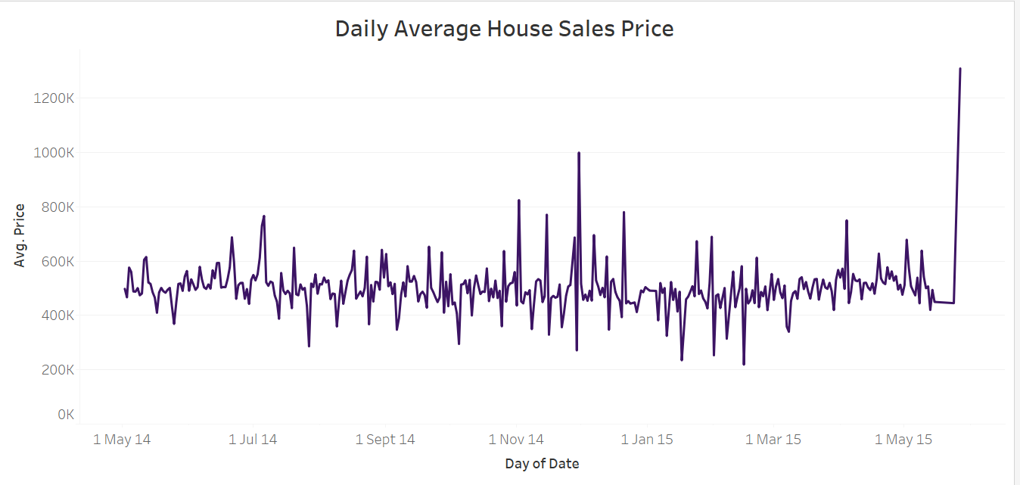

**3. Year Built vs. Average Price**

A bar chart shows the relationship between the year a house was built and its average sale price.

* **Insight:** Newer houses generally command higher prices, reflecting advancements in construction, design, and materials.

**4. Distribution of House Prices**

This histogram represents the distribution of house prices within the dataset.

* **Insight:** Most house prices fall between $200,000 and $600,000, with a few properties significantly exceeding $1,000,000. The skew towards the lower end suggests that the majority of houses are within a relatively affordable range.

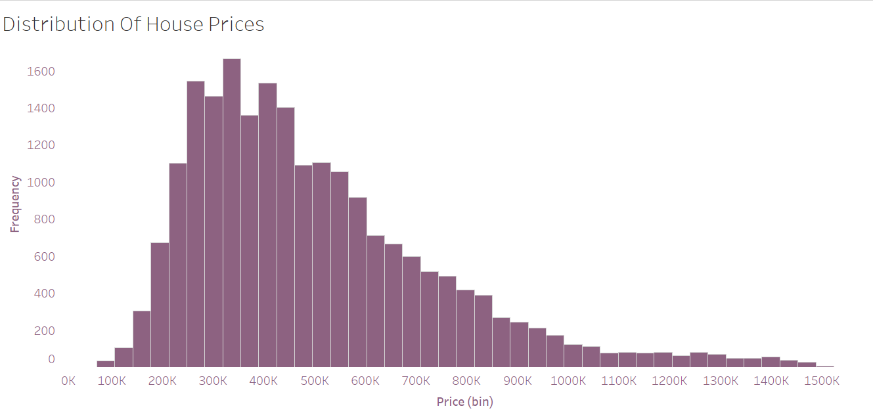

**5. Distribution of Bathrooms**

This bar chart shows the distribution of houses based on the number of bathrooms.

* **Insight:** The majority of houses have either 2 or 3 bathrooms, which are common configurations for family homes in the region.

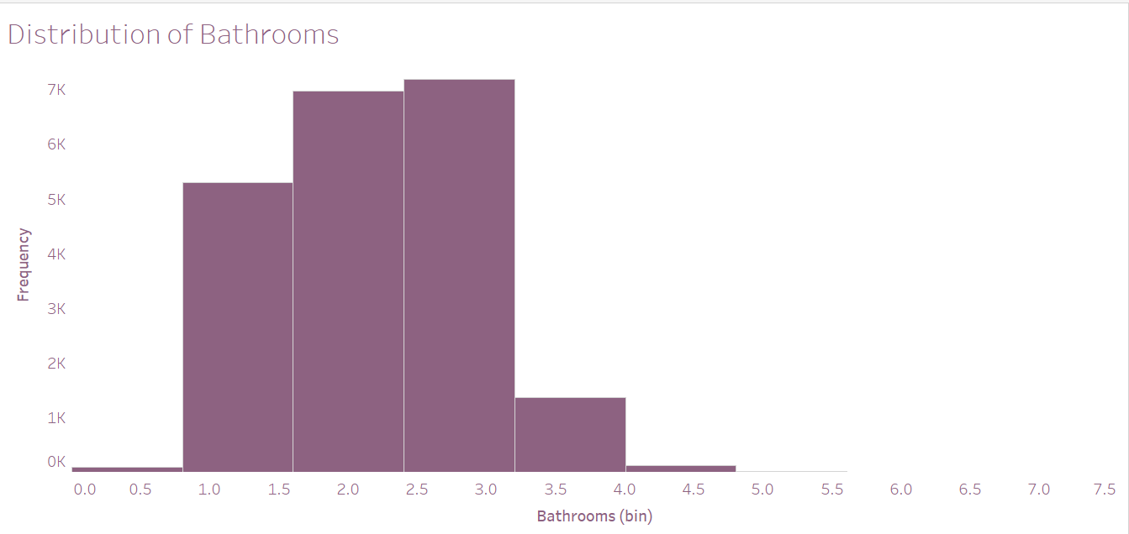

**6. Calendar Heatmap**

A calendar heatmap represents the number of house sales occurring on each day.

* **Insight:** The sales are evenly distributed across the month, with certain peak days indicating higher transaction volumes.

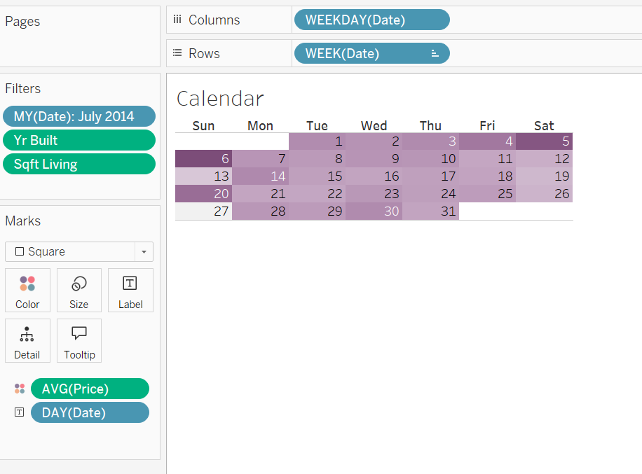

**7. Map**

A geographical map illustrates the distribution of house sales across different regions in Washington state.

* **Insight:** Sales are concentrated in and around major cities like Seattle, Tacoma, and Olympia, reflecting urbanization trends and the demand for housing in these areas.

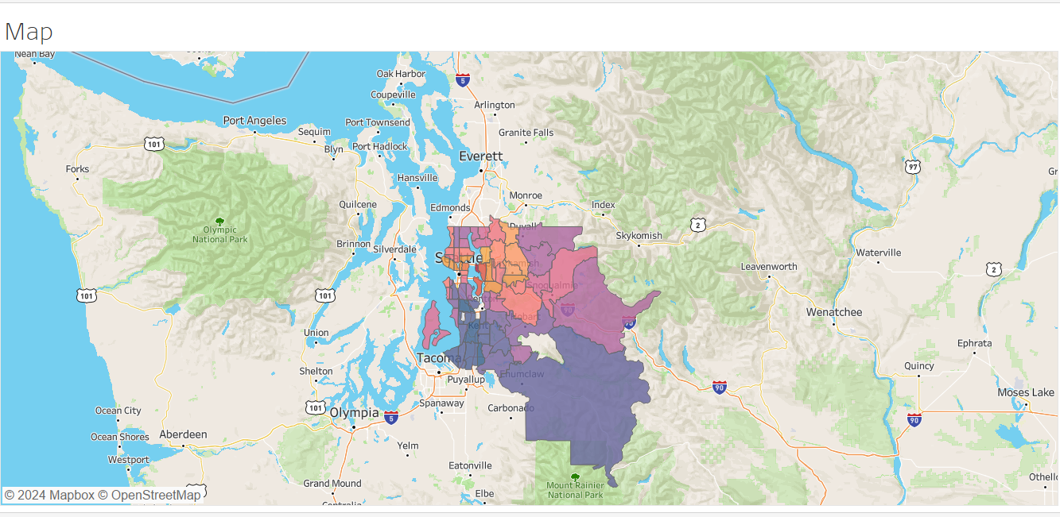

**Conclusion**

This Tableau dashboard provides a comprehensive analysis of house sales in Washington state, allowing for the identification of key trends and insights. The strong correlation between view quality, house condition, and sales price suggests that these are critical factors influencing buyer decisions. The data also highlights the significance of newer constructions and popular bathroom configurations. Overall, this dashboard serves as a valuable tool for real estate professionals, investors, and policymakers to make informed decisions based on historical sales data.